# Exercises: WordPress Intro

Problems for exercises and homework for the [“WordPress Basics” course @ SoftUni](https://softuni.bg/courses/wordpress-basics).

In this homework, you are supposed to install **XAMPP** and a local **WordPress** (WP) site and create some content in your WordPress instance, then register for a free **hosting**, install WordPress in Internet and purchase and configure a free **domain** name for your WordPress site.

## Download, Install and Run XAMPP

Download **XAMPP** (the latest version) from <https://www.apachefriends.org/download.html>.

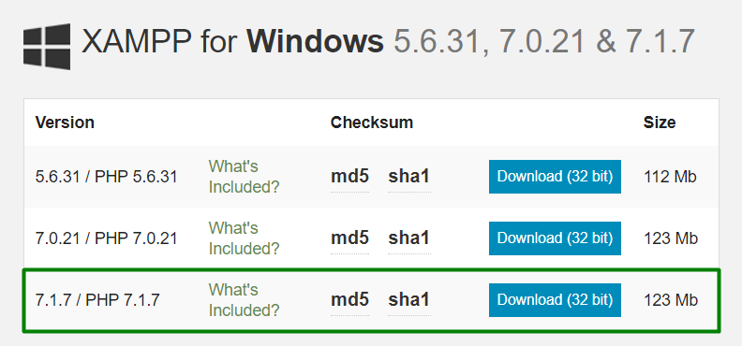

### XAMPP Installation

The screenshots below will show you the steps that you need to go through, in order to successfully install XAMPP (for Windows users).

Install XAMPP in the **default directory** (“**C:\xampp**”), or you might encounter permission troubles later on.

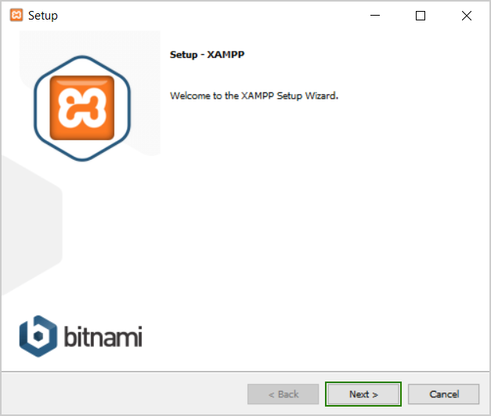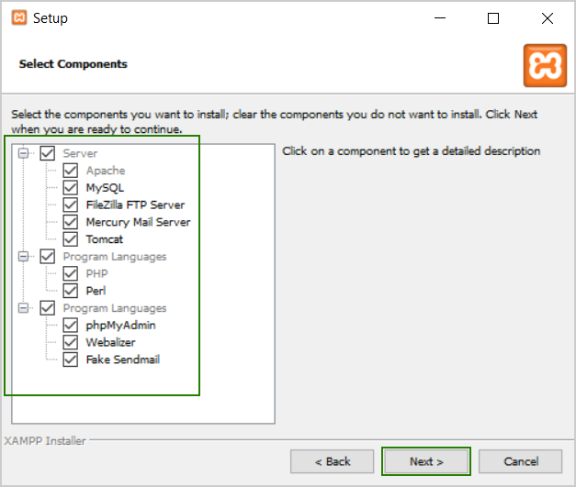

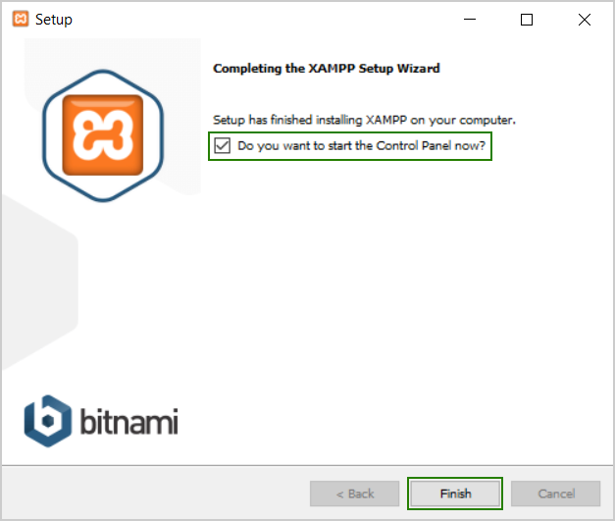

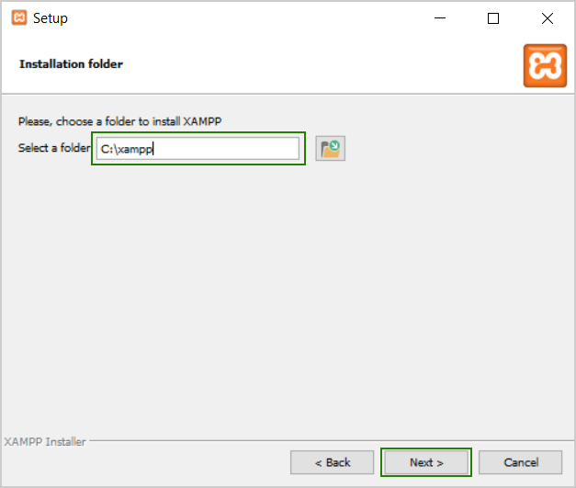

### XAMPP First Start

The first time you **start XAMPP** you will get **language selection screen** like this one:

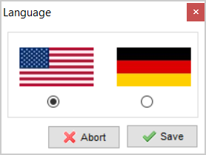

### XAMPP Control Panel

After you choose the language you prefer, you will see the **XAMPP Control Panel**:

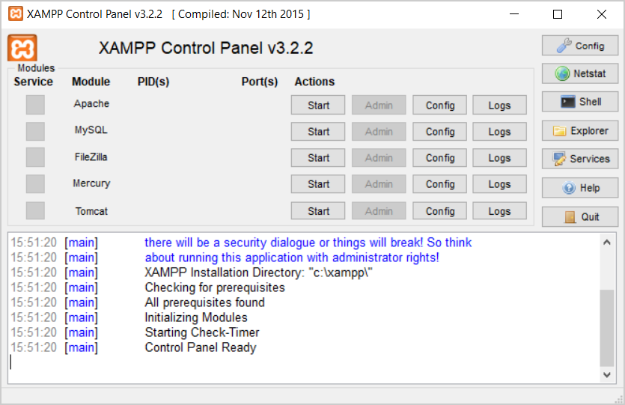

## Start Apache + MySQL

### What is Apache?

**Apache** is a **Web server**, used to run the WordPress (its PHP scripts) and serve Web content to user’s Web browsers. All Web sites need a Web server. WordPress typically uses Apache with PHP installed with it.

### What is MySQL?

**MySQL** is a **database** that holds the WordPress data (posts, articles, users, etc.). It is a separate software, installed as part of XAMPP. Developers may explore the MySQL databases using **phpMyAdmin** (database administration software coming with XAMPP).

### Start Apache and MySQL from XAMPP Control Panel

To install WordPress, first you need to **start Apache** and **MySQL** from the XAMPP control panel:

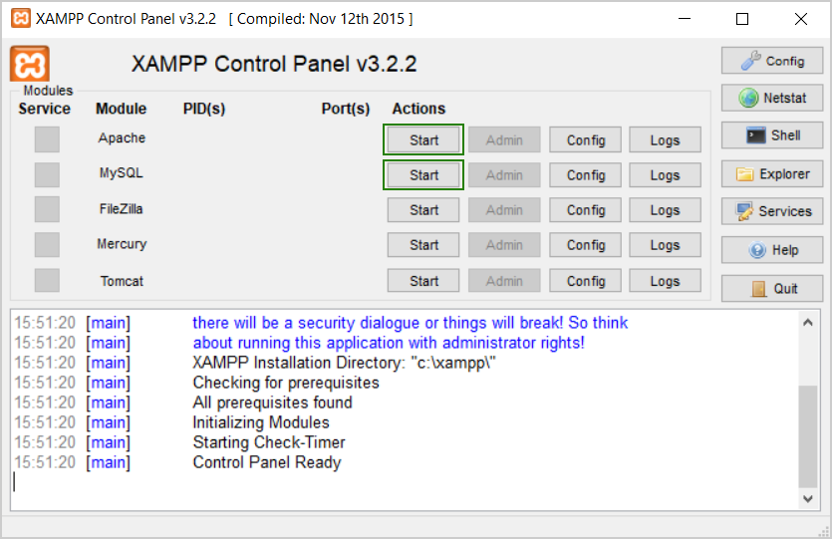

Once you launch them, you should see their status turned to **green**:

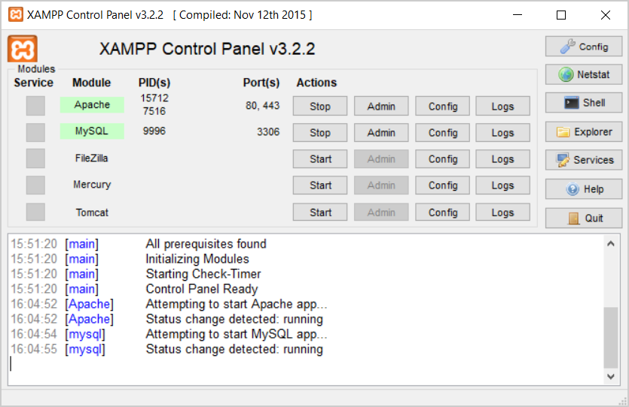

### Ensure Port 80 is Free

If you have **Skype** or a torrent client running, the Apache server **will not start**. You need to **stop the program that holds TCP port 80**, and the Apache server will start. You may configure Skype to use different port number:

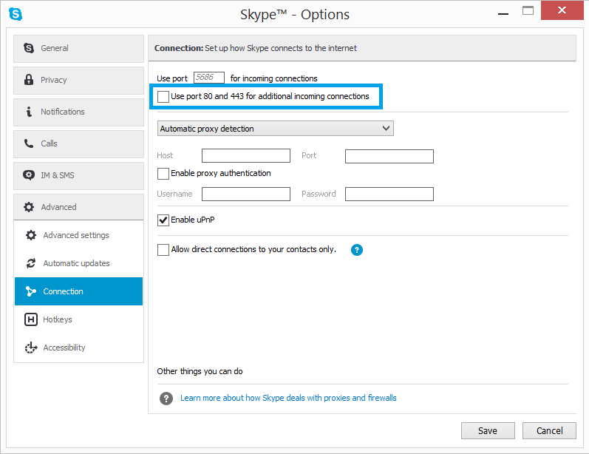

### Test the Apache Web Server

And now you should be able to test that your local server is working by going to <http://localhost/> in your Web browser of choice:

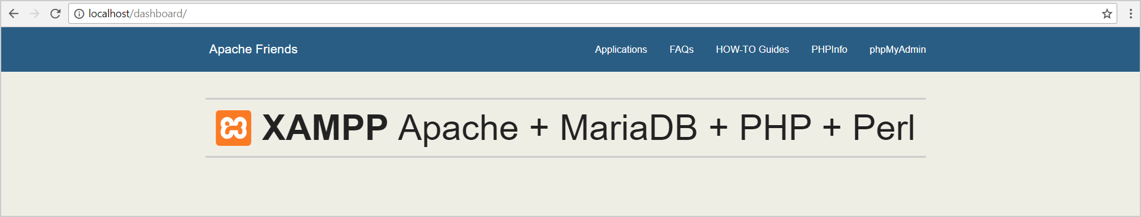

## Install WordPress in XAMPP

### Download WordPress

Go to <https://wordpress.org/download/> and download the latest **WordPress** stable release as ZIP file, e.g. wordpress-4.8.zip.

### Create a Folder for Your WordPress Instance

Navigate to the folder where you installed XAMPP. That’s usually C:\xampp. Then, in that folder, find the htdocs subfolder. This is the Web server’s “**document root**” – the folder visible from <http://localhost>.

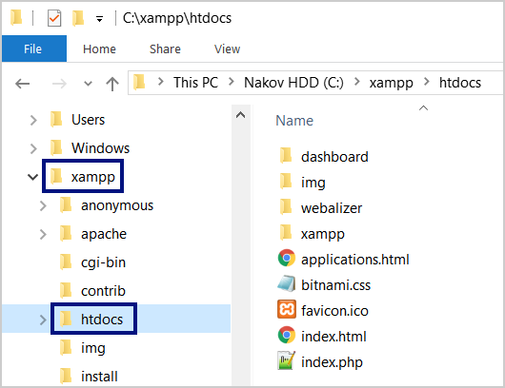

In htdocs, create a new folder for your Web Site. This folder name will become the sub-name used to access your site. For example, if you make the folder pizzasite, you’ll access your site by opening <http://localhost/pizzasite>.

### Unzip the WordPress Package

Once you create the folder, extract the wordpress-4.8.zip file you downloaded from **wordpress.org** into it. Ensure you do not have additional subfolders. The site content should look like the screenshot below:

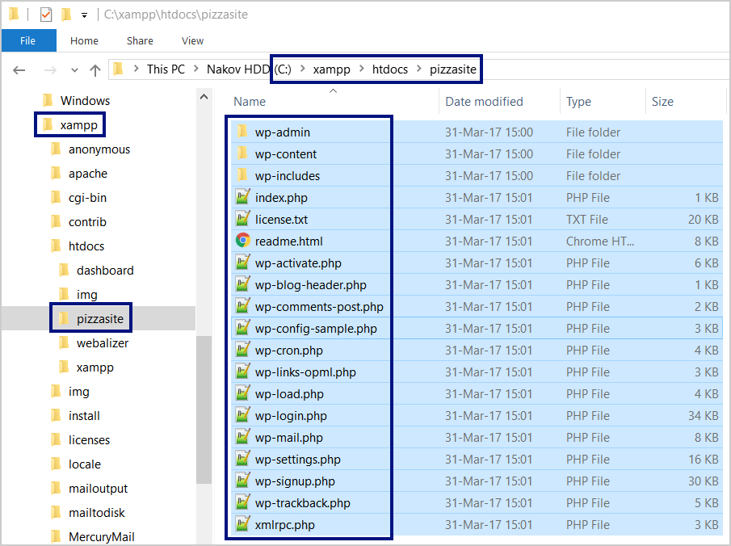

### Create MySQL Database

Now create a **MySQL database** using **PhpMyAdmin**. Open it from the **[Admin]** button in XAMPP Control Panel:

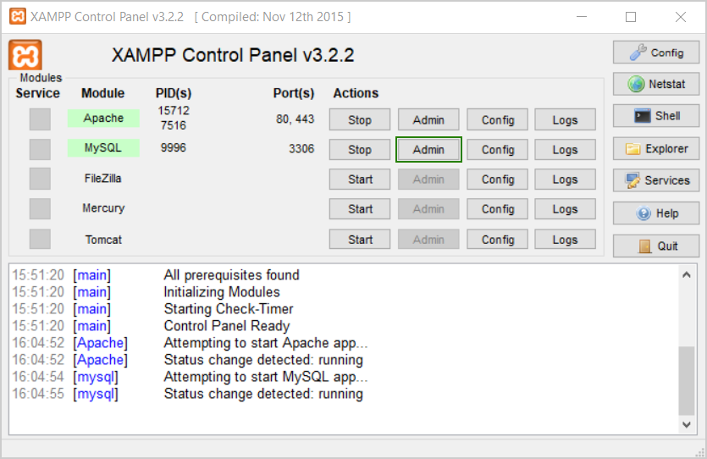

Then click on **[Databases]** tab at the top navigation:

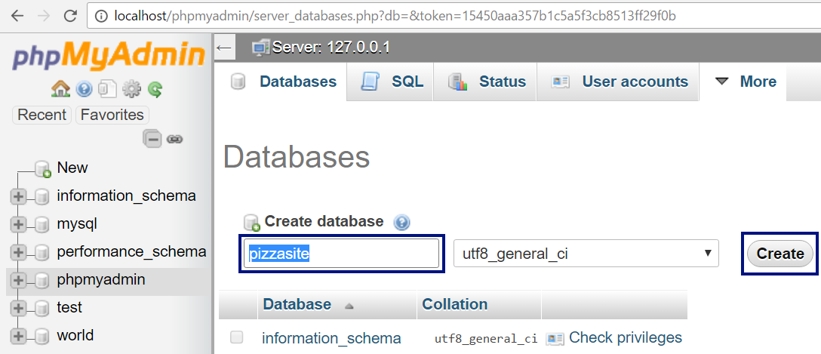

Enter a **database name** for your database and click **[Create]**. Your name should be something meaningful. Remember it because you’ll need it for the next step.

### Run the WordPress Installation

Now open [http://localhost/<your_folder>](http://localhost/%3cyour_folder%3e), e.g. <http://localhost/pizzasite>. The WordPress Installer will run automatically to help you configure the WordPress instance:

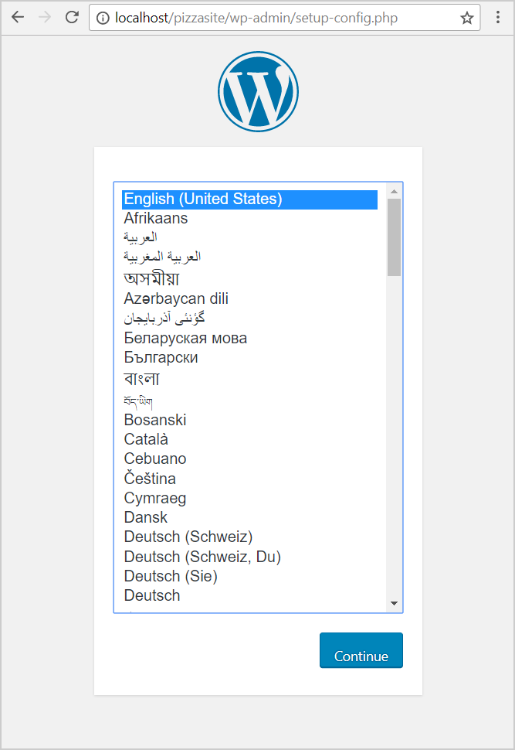

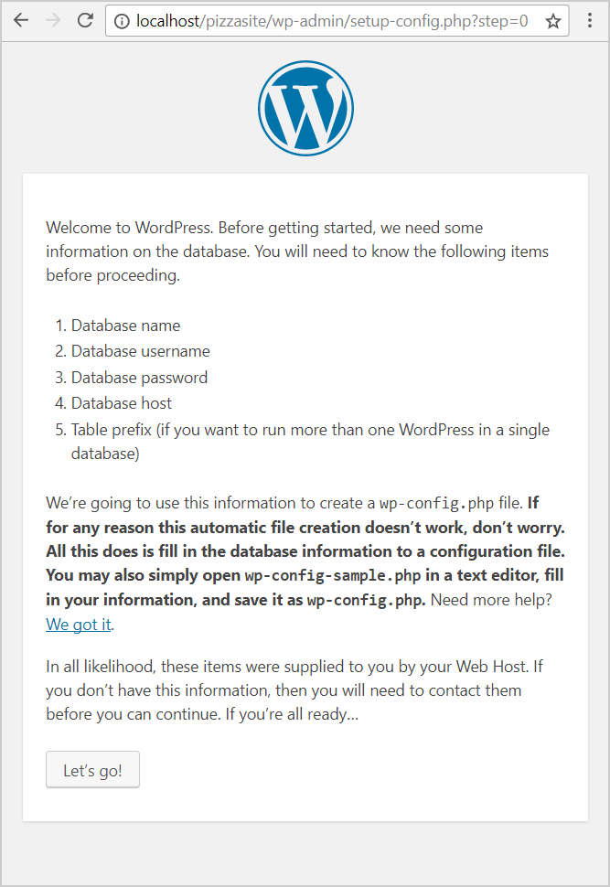

Enter your database connection settings. In XAMPP the usual MySQL **username** is “root” and the **password** is usually **empty** (no password). The **database name** is what you used when you created a database in **phpMyAdmin**. The database host is “localhost”. The usual prefix for the WordPress tables in the MySQL database is “wp_”. Just leave it untouched.

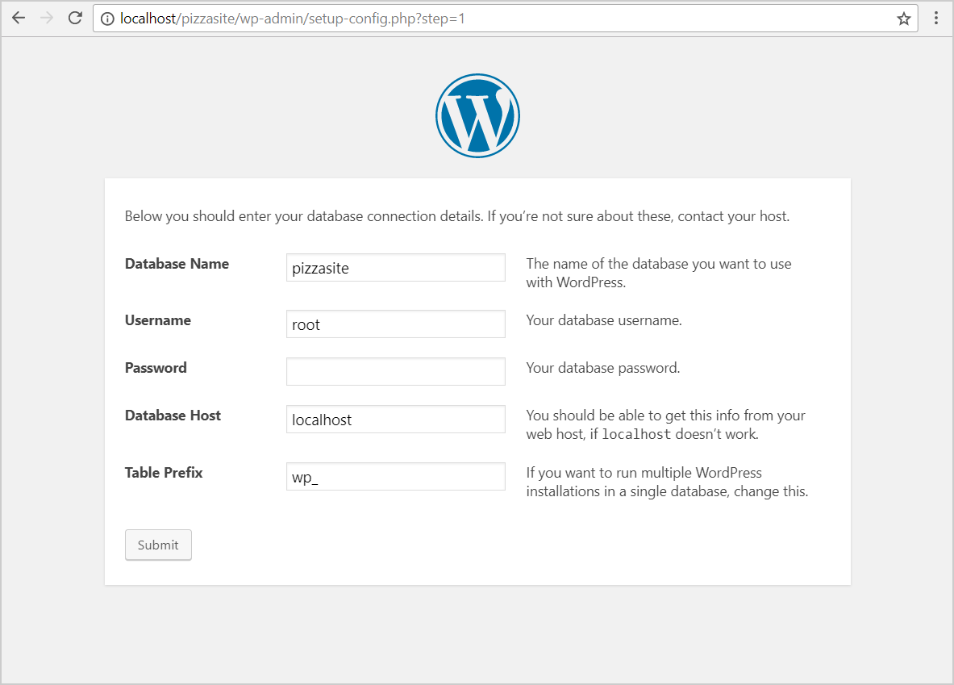

Continue the WP installation:

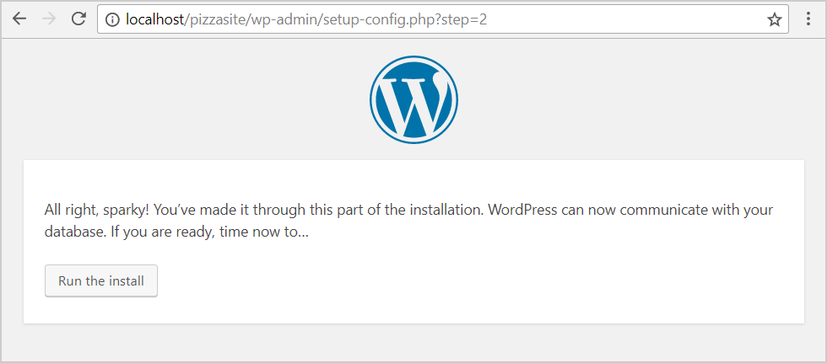

Enter some **details** about your new WordPress Web site. Remember the administrator’s **username** + **password**.

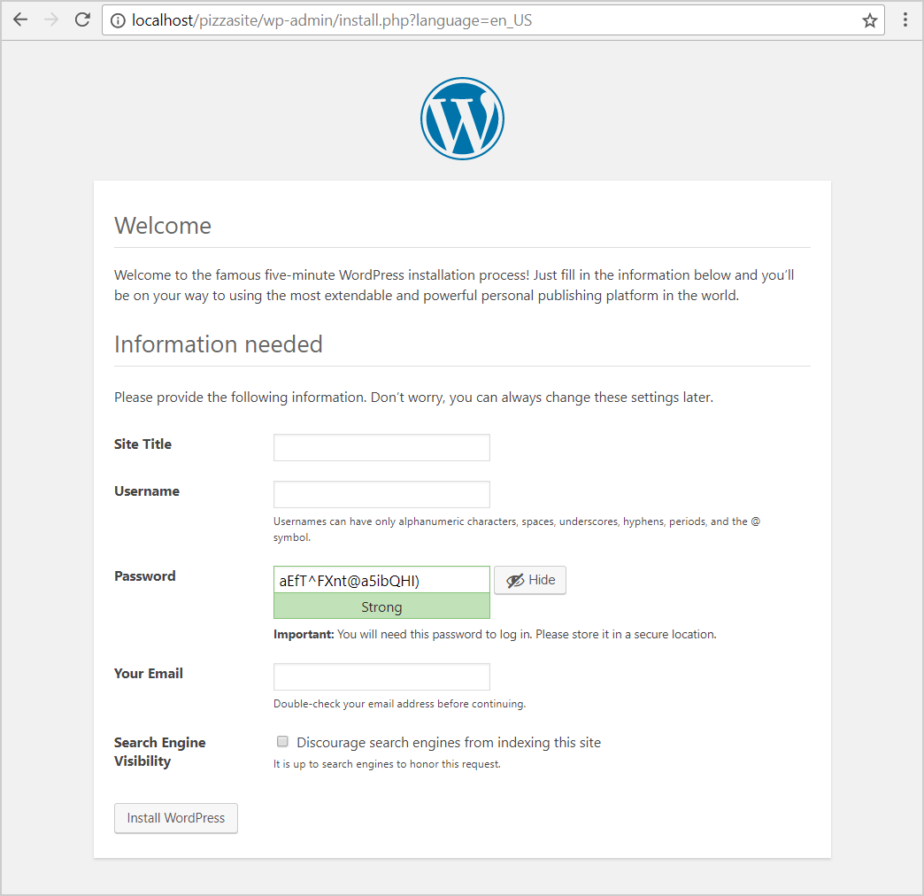

Finally, **finish the rest** of the WordPress install process. You should see your brand-new WordPress site running on your local host (in your XAMPP):

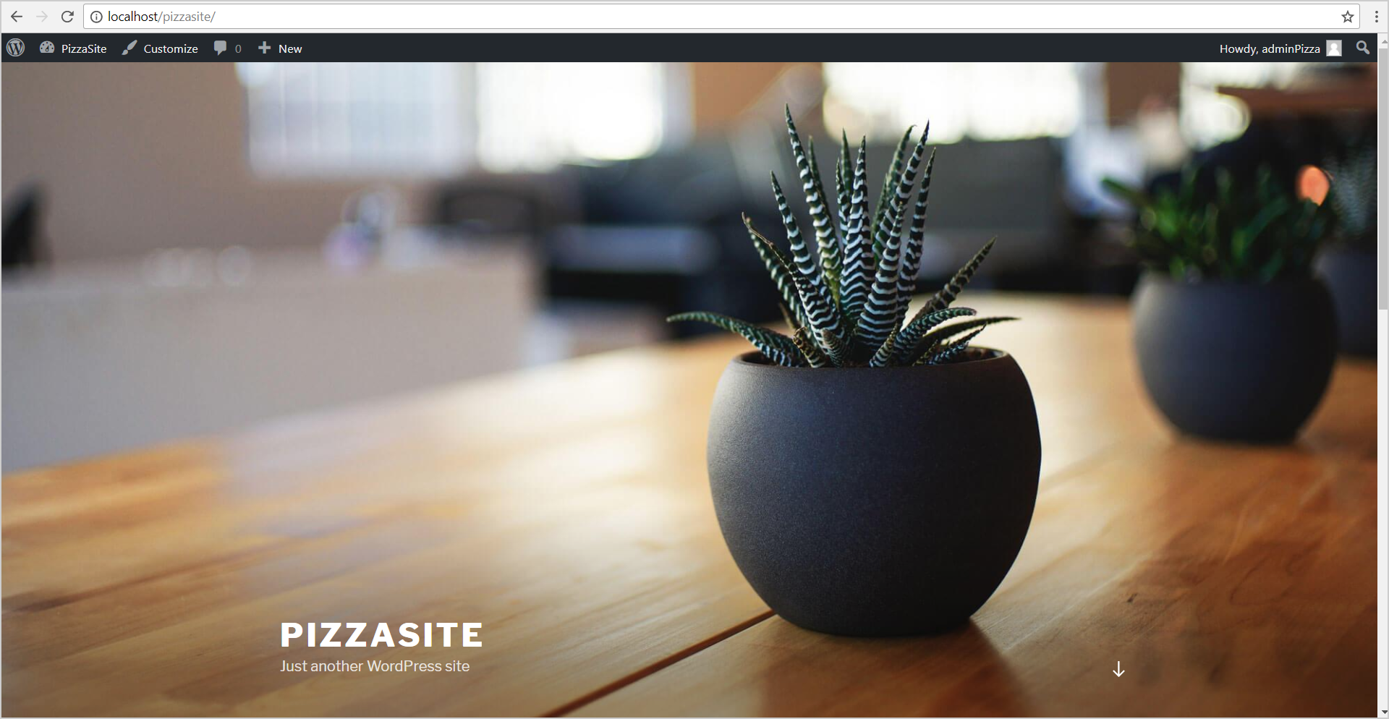

## Create Posts and Pages

Create a few posts, pages, categories, tags, users, etc. Just play a bit with your first WordPress site. Open the WordPress admin panel: [http://localhost/pizzasite/**wp-admin**](http://localhost/pizzasite/wp-admin).

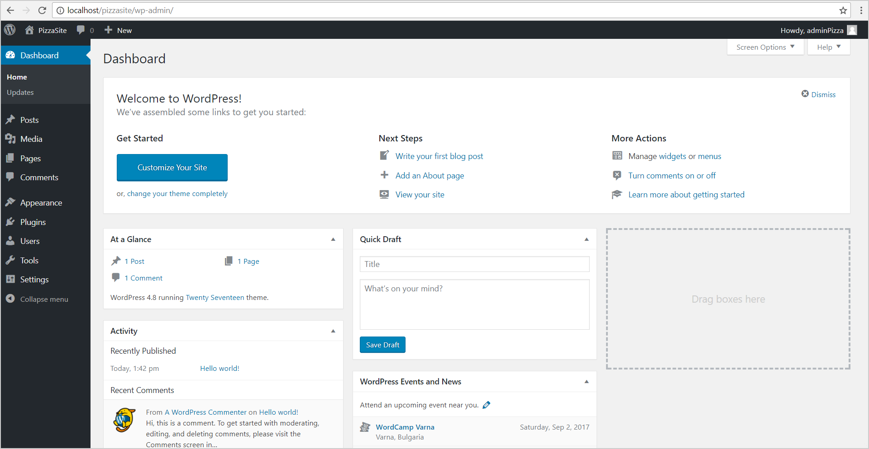

Now add a few posts with tags and click **[Publish]**.

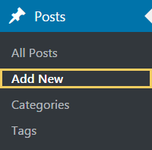

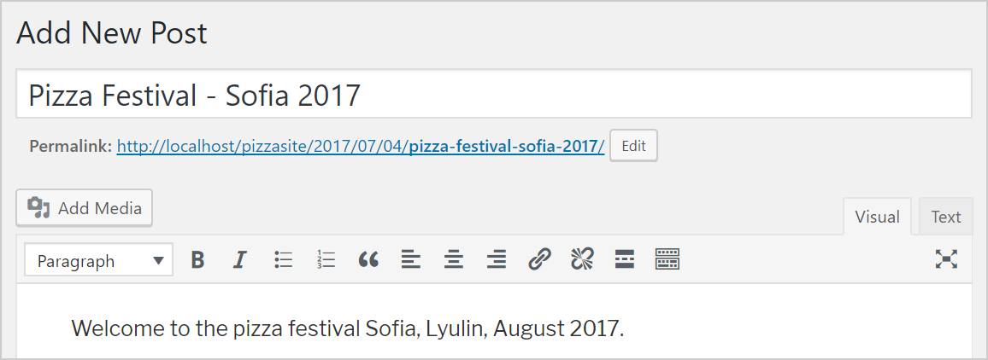

Now add some **tags** and publish your new content.

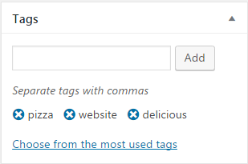 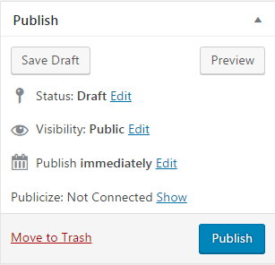



Now create a few **pages**:

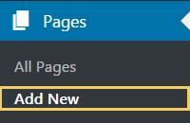

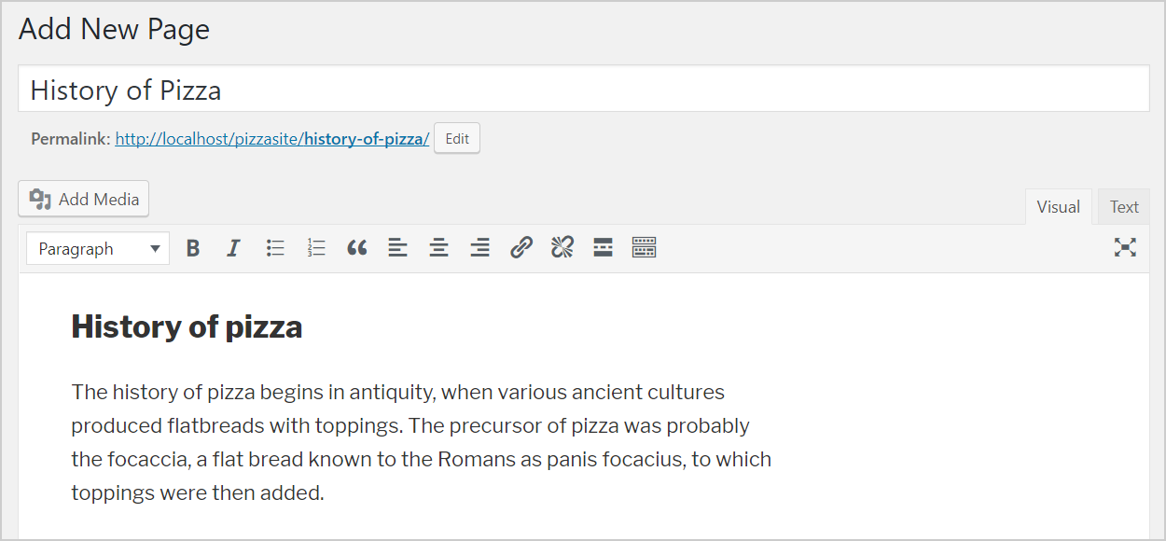

Click **[Publish]** to see your new page. Now add a few **categories**:

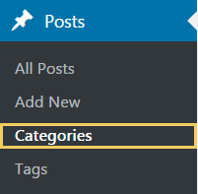

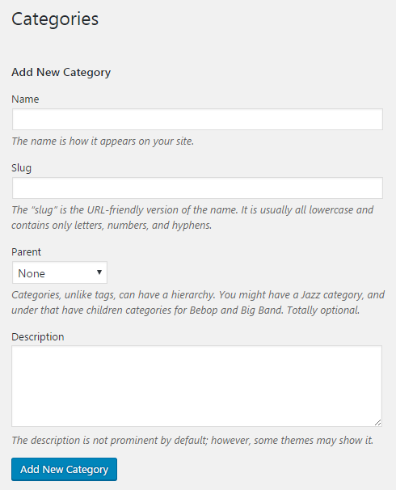

Now click **[Add New Category]**. Assign the posts and pages into the categories.

You are done with your local WordPress installation. Note that this is a **local Web site**. It cannot be accessed from Internet and it will stop working if you power off your computer or stop XAMPP.

## Register Free Hosting Account (cPanel)

Now let’s move further: create a **WordPress site in Internet**. This Web site will be available for anyone with Internet connection. You will be able to open it though your laptop or smartphone.

### What is a Web Hosting?

Sites in Internet need a **Web hosting**. This is computer hardware + software infrastructure that runs your Web site. Your **hosting account** holds your Web sites + their data (files + databases).

Hosting companies may provide **free** or **paid hosting**. Usually, the **free hosting** is not good for real projects but is ideal for educational purposes. Let’s create a free hosting account.

### Create a Free Hosting Account

Register a free hosting account + subdomain from [http://freesubdomain.org](http://freesubdomain.org/):

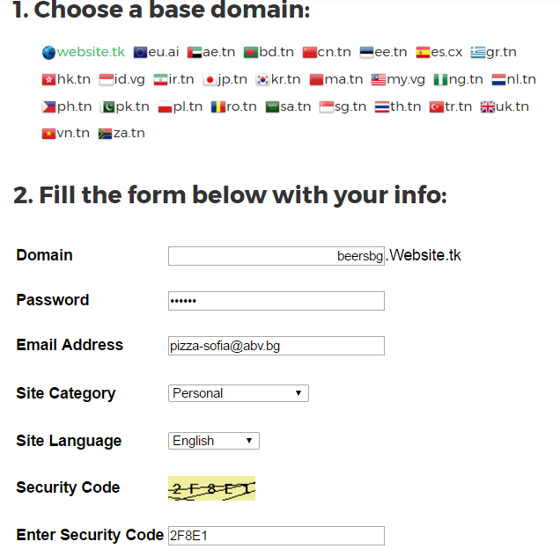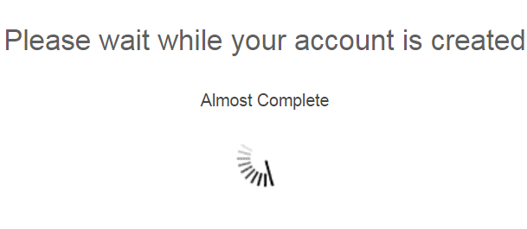

### Open cPanel

Remember the account information shown after the registration. It holds the credentials to administer your hosting. Now click on **[cpanel.website.tk]** and log in:

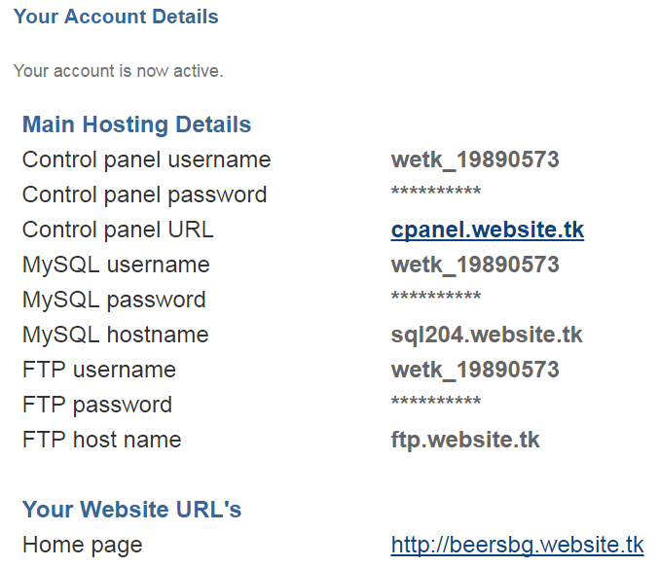 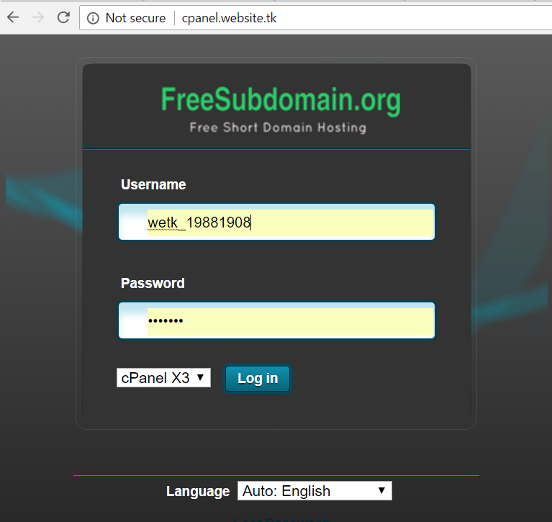

### What is cPanel?

**cPanel** is popular Web hosting administration software used by many hosting companies. It provides functionality to manage your **domains** (add-on domains + subdomains), web **sites**, MySQL **databases**, **files** and folders, **email** accounts and forwarding, etc. When you get a hosting account, you will be given an access to some machine in Internet, that can hold multiple web sites, their files and folders, databases and will run them (like XAMPP on your local machine).

### Explore cPanel

Feel free to explore the cPanel functionality:

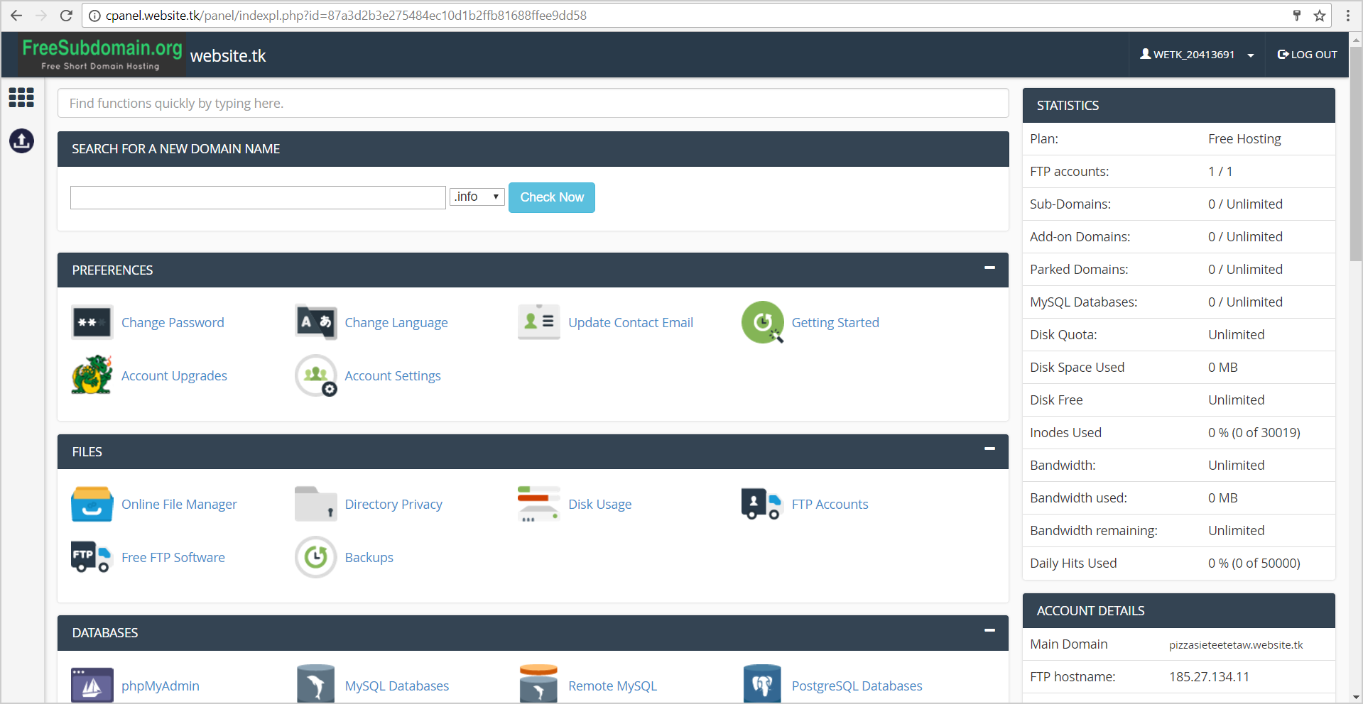

## Install WordPress with Softaculous

Install WordPress using **cPanel** and **Softaculous**. Click on the **[Softaculous]** icon.

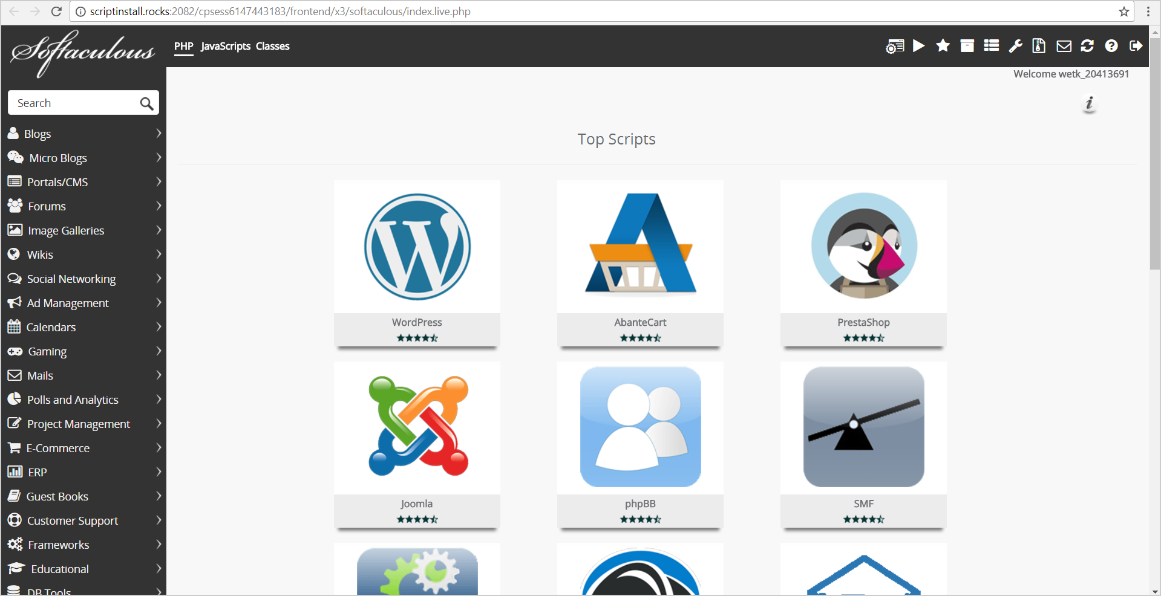

Choose the **[WordPress]** icon:



Now you need to **configure your WordPress instance**. Choose a **domain** from yours. Leave the “**Directory**” **empty**.

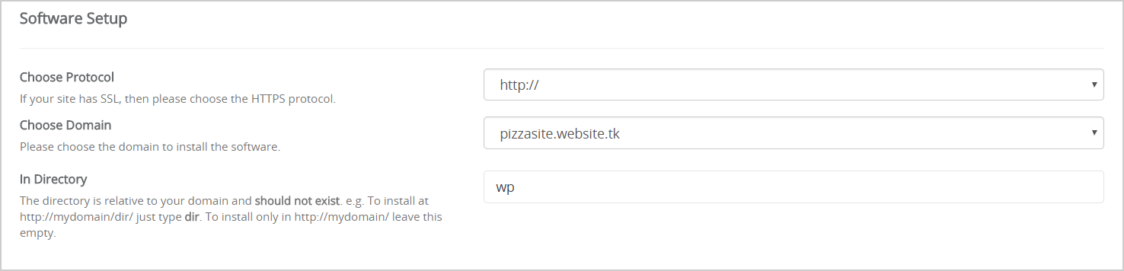

Enter a **title** and **description** for your new WordPress site:

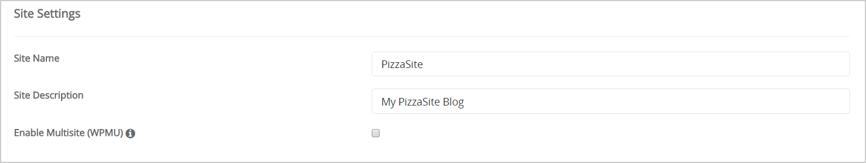

Enter a **username** + **password** for your WordPress administrator account:

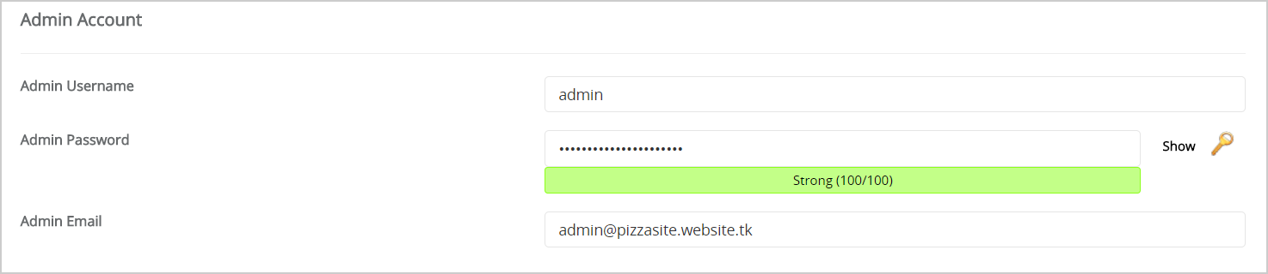

Now click **[Install]** and you should see the installation progress bar. Finally, your WordPress site should be ready:

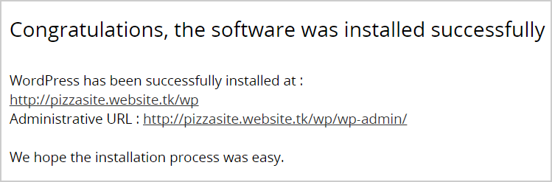

Open your new WordPress site from your Web browser:

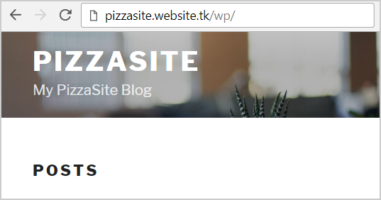

## Register a Free Domain from Freenom

### What is a Domain and Subdomain?

In Internet, Web sites may have **domain** names for easier access. Domains may be **free** (like pizzasite.cf or randomdomainname.ml) or **paid** (like nakov.com and softuni.bg). One domain usually holds one Web site and gives an easy-to-remember name for it. **Subdomains** may hold different web sites within a parent domain, e.g. marinara.pizzasite.cf, **margherita**.pizzasite.cf, random.randomdomainname.ml.

### What is a DNS Server?

Domains are handled by a complex network of DNS servers (domain to name servers). The DNS servers know the IP address for a domain and subdomain. For example, the domain margherita.pizzasite.cf may have **IP address** 185.27.134.160. The **IP address** is a unique machine number in Internet (your hosting machine number).

### Register for a Free Domain from Freenom

**Freenom** is a provides free domains in Internet. Open Freenom: <https://my.freenom.com/domains.php>. Register a **free domain name**, e.g. pizzasite.cf. Use .cf or .ml or .ga domain, not .tk (because .tk domains do not work with hosting from website.tk).

Choose “***Use your own DNS***”. This tells the domain registrar to keep the information about your new domain (the so-called **DNS zone**) in your hosting account. Thus, you will be able to create subdomains and manage your domain settings from your **cPanel**. Enter the **DNS servers** coming with your cPanel account (in our case ns1.website.tk and ns2.website.tk):

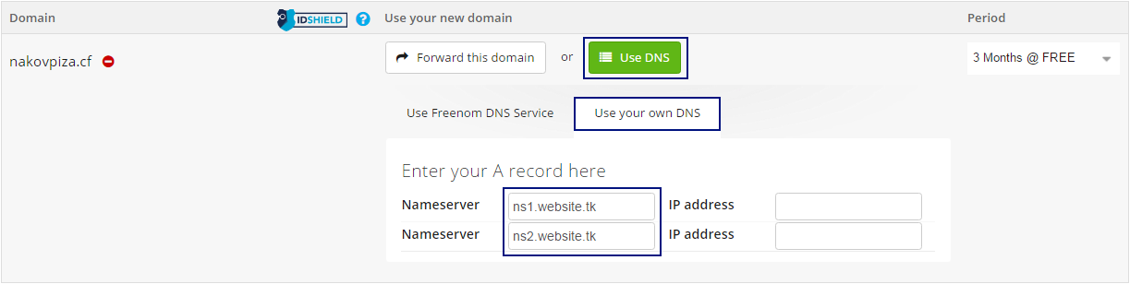

You may need to ask your hosting provider about their DNS servers if they are not shown in your cPanel.

**Important**: you need to **wait 5-10 minutes** until your domain is activated! It may take even more, up to 8 hours. First, the domain registrar (in our case Freenom) should create the data about your new domain. Then, it should become visible, which is not instantly.

### Alternatives of Freenom

If Freenom cannot register you, use some other free domain registrar. Here are few others:

* [http://usa.cc](http://usa.cc/)
* <http://www.registry.cu.cc>

## Managing Domains and Sub-Domains from cPanel

To activate your domain name, you need to **add your domain in your hosting account** through cPanel. Otherwise the domain will have no DNS zone and will not work.

### Add-on Domain in cPanel

This is how to add a top-level **domain** in cPanel:

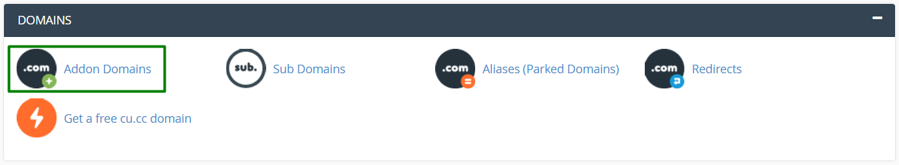

Enter your domain name. It **should be already successfully registered** by the registrar (Freenom in our case).

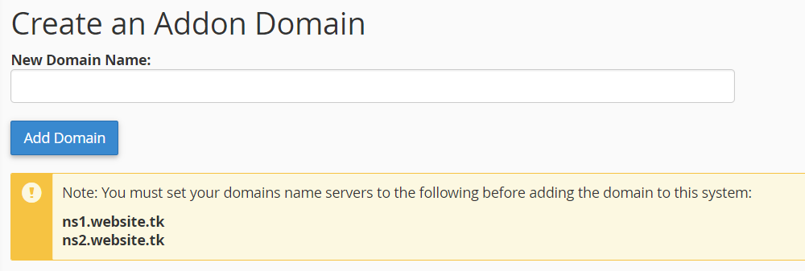

In the successful scenario, a message like show below will appears. It says that the domain is **added successfully** in your hosting account and your hosting’s DNS servers now know how to handle it.

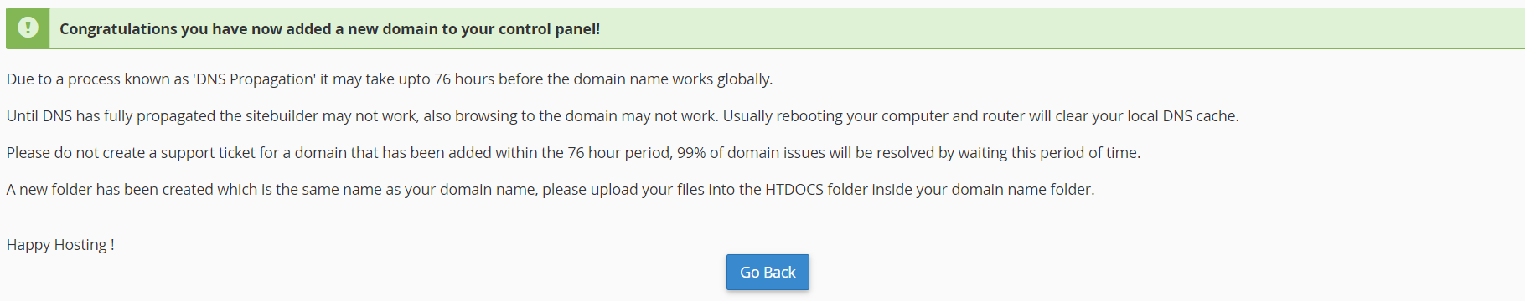

Sometimes, the above procedure will end with an **error message**. Check if your domain name is correct, whether it is registered by your registrar and wait a few minutes, then repeat again.

### Creating a Subdomain

You may manage your **sub-domains** from cPanel:

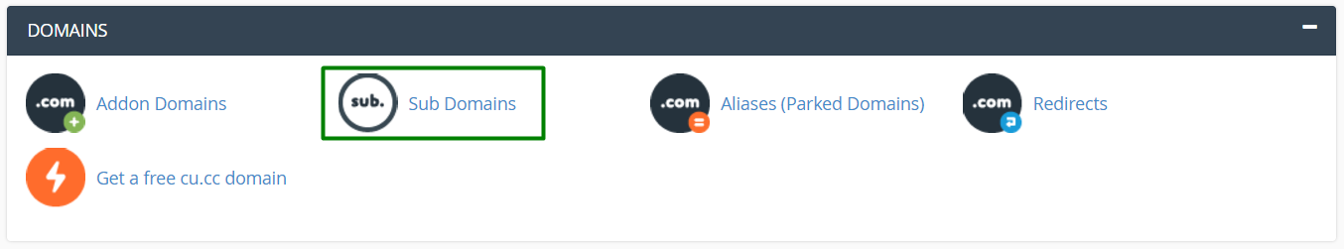

**Subdomains** are added in cPanel similarly, like domains:

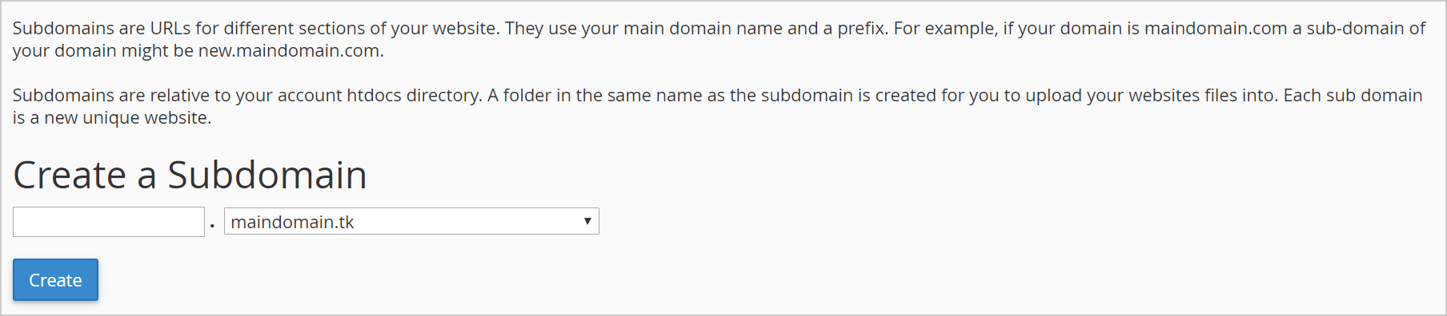

Each **domain** / **subdomain** has a **home directory** (document root for the Web server):

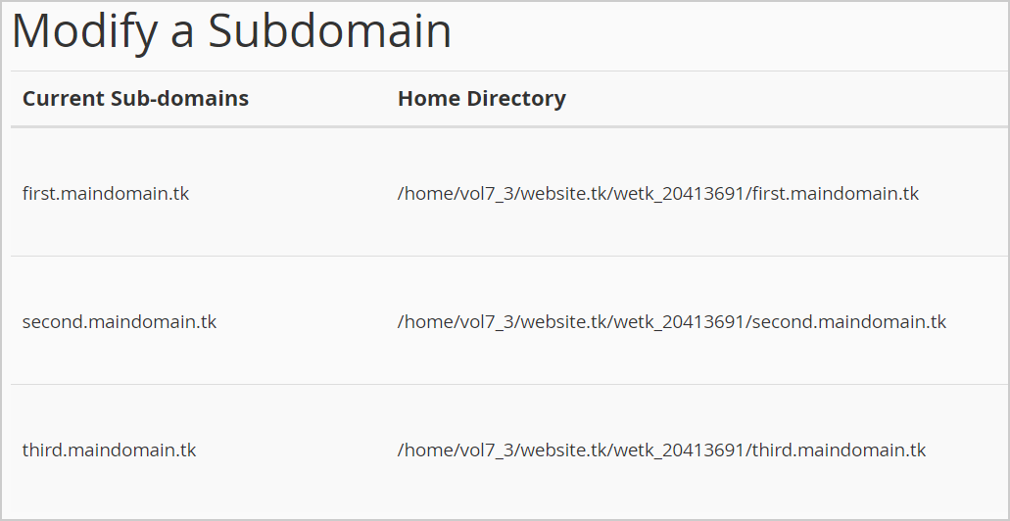

### Add Web Content for a Domain / Subdomain

Add something at your Web site behind your domain. Each domain name has its own htdocs (document root) directory at the hosting server. You may open the **[Online File Manager]** from your cPanel and create a file named “index.html” in your folder for your domain.

First **open the folder** holding the files for your new domain:

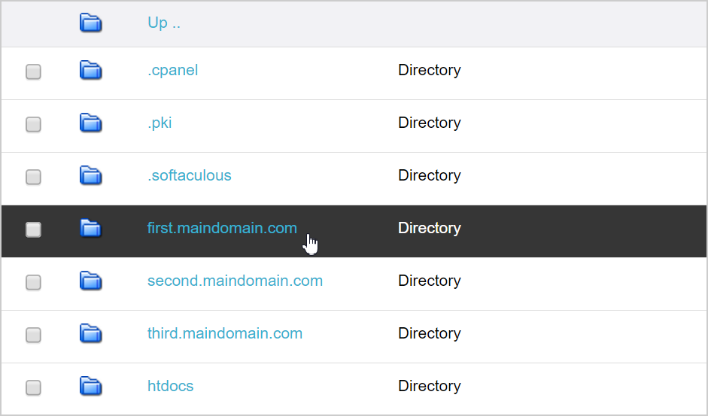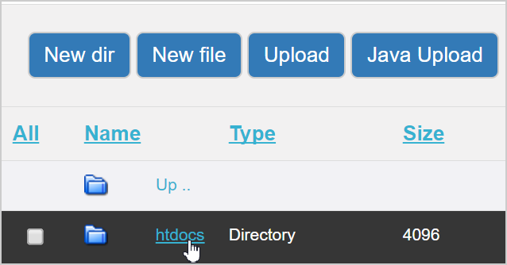

After that **create a new file** “index.html”for your Web site. Put something in it:

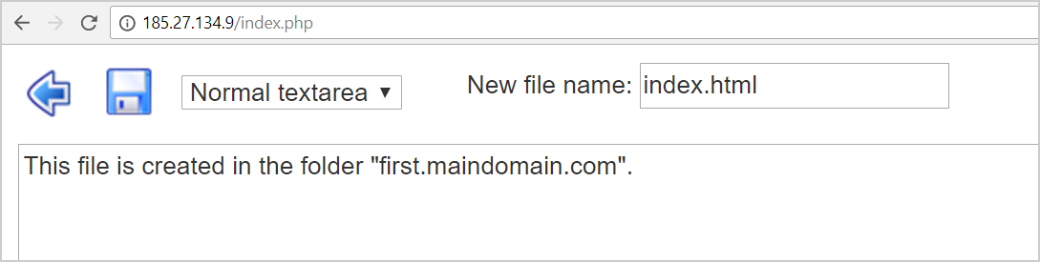

Now **save** the file and open **your Web site**:

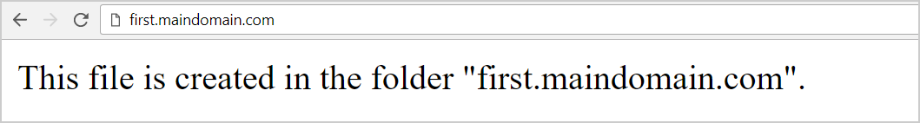

### Install WordPress for Your Domain / Subdomain

Using **Softaculous** from your cPanel install WordPress for your new domain. The steps were already shown before.

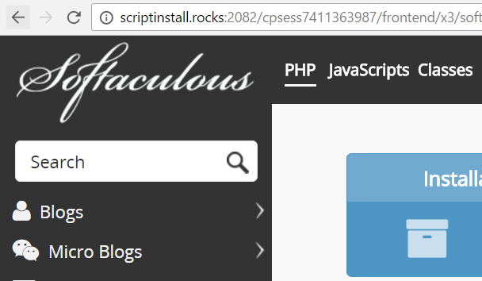 

Open again your Web site. **Refresh** forcefully your Web Browser using **[Ctrl+F5]**. It should open your new WordPress installation:

# What to Submit

Create a **text file** or **Word document** or **PDF** (e.g. trifon-wordpress-homework.txt) holding your assets:

1. A **screenshot** of your local **XAMPP installation**, e.g. <http://i.imgur.com/DM9oWIq.png>
2. A **screenshot** of your local **WordPress installation**, e.g. <http://i.imgur.com/DpJijiZ.jpg>
3. **URL** of your **main hosting website**, e.g. <http://nakov.website.tk>. It should hold a non-empty content.
4. **URL** of your **add-on domain website**, e.g. <http://nakov.cf>. It should hold a WordPress installation.
5. **URL** of your sub-domain website, e.g. <http://svetlin.nakov.cf>. It should hold a WordPress installation.

Submit your text file (or document) as **homework** at the course Web site.